Total Rentals & Season

----------------------------------------------------------------

&nbsp; Estimate Std. Error t value Pr(>|t|)

----------------- ---------- ------------ --------- ------------

\*\*(Intercept)\*\* 116.5 3.346 34.81 1.165e-256

\*\*x\*\* 29.18 1.223 23.85 9.182e-124

----------------------------------------------------------------

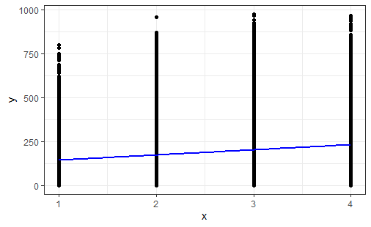

Total Rentals & Humidity

--------------------------------------------------------------

&nbsp; Estimate Std. Error t value Pr(>|t|)

----------------- ---------- ------------ --------- ----------

\*\*(Intercept)\*\* 379.9 4.43 85.76 0

\*\*x\*\* -303.6 6.75 -44.98 0

--------------------------------------------------------------

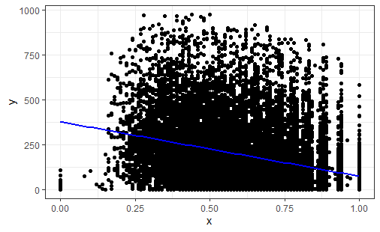

Total Rentals & Weather Situation

--------------------------------------------------------------

&nbsp; Estimate Std. Error t value Pr(>|t|)

----------------- ---------- ------------ --------- ----------

\*\*(Intercept)\*\* 247.1 3.328 74.24 0

\*\*x\*\* -40.41 2.13 -18.97 1.98e-79

--------------------------------------------------------------

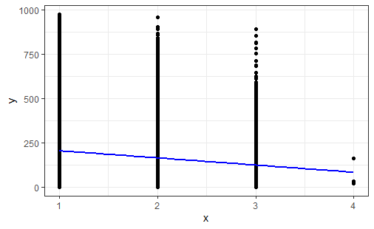

Total Rentals & Wind Speed

---------------------------------------------------------------

&nbsp; Estimate Std. Error t value Pr(>|t|)

----------------- ---------- ------------ --------- -----------

\*\*(Intercept)\*\* 163.2 2.531 64.46 0

\*\*x\*\* 2.063 0.1671 12.34 7.282e-35

---------------------------------------------------------------

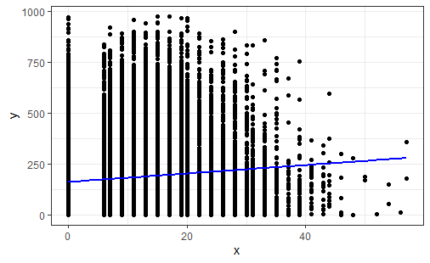

Total Rentals, Temp C & Working Day

----------------- ---------- ------------ --------- -----------

\*\*(Intercept)\*\* 40.38 4.176 9.671 4.57e-22

\*\*x1\*\* 9.644 0.2414 39.95 0

\*\*x2\*\* 37.59 5.184 7.251 4.3e-13

\*\*x1:x2\*\* -2.304 0.2953 -7.803 6.387e-15

---------------------------------------------------------------

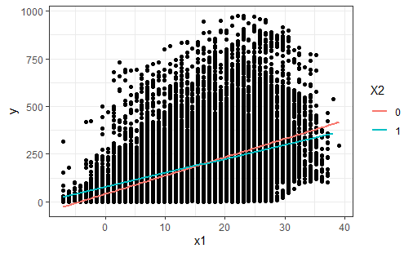

Total Rentals, Temp C & Season

---------------------------------------------------------------

&nbsp; Estimate Std. Error t value Pr(>|t|)

----------------- ---------- ------------ --------- -----------

\*\*(Intercept)\*\* 34.68 4.984 6.957 3.594e-12

\*\*x1\*\* 9.106 0.4328 21.04 4.548e-97

\*\*x2\*\* 15.04 2.077 7.24 4.68e-13

\*\*x1:x2\*\* -0.5459 0.1645 -3.319 0.0009059

---------------------------------------------------------------

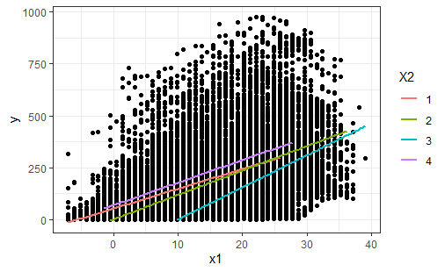

Total Rentals, Wind Speed & Weather Situation

----------------------------------------------------------------

&nbsp; Estimate Std. Error t value Pr(>|t|)

----------------- ---------- ------------ --------- ------------

\*\*(Intercept)\*\* 189.9 6.172 30.77 1.713e-202

\*\*x1\*\* 4.436 0.393 11.29 1.923e-29

\*\*x2\*\* -19.32 4.004 -4.826 1.405e-06

\*\*x1:x2\*\* -1.608 0.2506 -6.418 1.415e-10

----------------------------------------------------------------

